**GAMES , SERVICES, CONTACT, SOCIAL CONNECT**

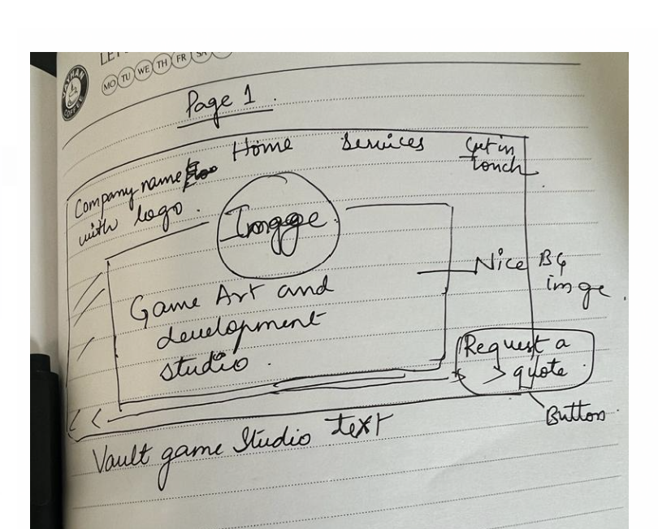

**Tags will be – About us ( will show what we do – our games portfolio, art in unreal pc and unity games art work) – with small video if possible.**

**VAULT GAMES STUDIO**

**Play games everyday!**

**offers end-to-end services for game development in Unity3D, Unreal, PlayCanvas, game design and more.**

**OUR SERVICES: TAG**

**Building games from ideation to finish.**

**What we do?**

**We are specialized in developing extraordinary games with expertise in game art, development, animations and delivering top notch gaming experience for global users in various platforms.**

**Concepts to launch journey**

**GAME DEVELOPMENT –**

**Android game development, ios game development, gamification services, unity development, unreal development, pc games, mobile games, web3 games.game porting, 2d and 3d games porting,   
  
GAME ART**

**Concept art, casual art, hypercasual art, environment design, character design, game level design, game economy design, 2d and 3d art, game ui/ux, illustration services**

**GAME ANIMATION**

**2d animation**

**3d animation**

**Motion graphic animation**

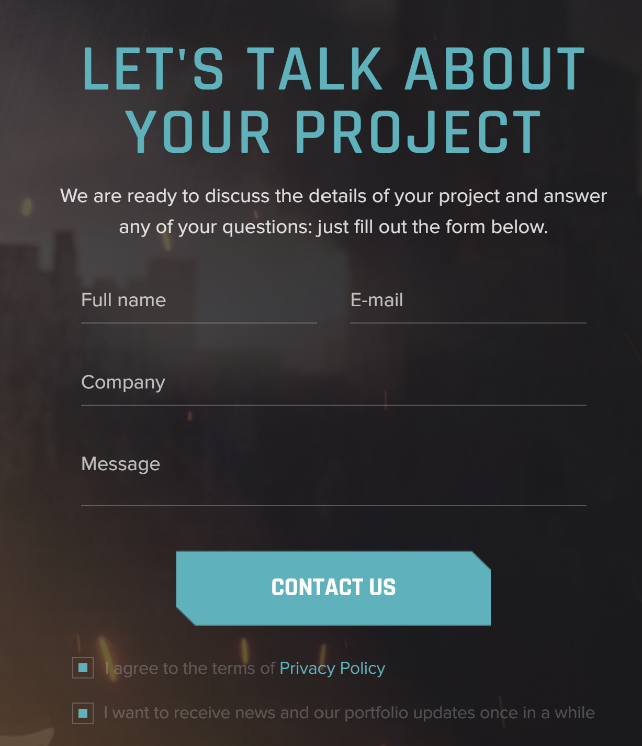

Address, contact details, social connect details

Ref websites:

<https://www.zynga.com/> (the best one)

<https://purpletalk.com/>

<https://www.streetlampgames.com/#About>

<https://www.underdogsthestudio.com/>

<https://kevurugames.com/portfolio/>

https://www.juegostudio.com/game-development-portfolios